

**HINDUSTAN AERONAUTICS LIMITED TRANSPORT AIRCRAFT DIVISION, KANPUR (UTTAR PRADESH)**

# SUMMER VOCATIONAL TRAINING REPORT

**ON**

**TO STUDY NAV-4000 AND COMMUNICATION SYSTEM IN AVIONICS**

**GUIDED BY** **SUBMITTED BY**

**Mr. AMIT AGARWAL Ankur Mohla Shaurya Gupta**

**Sr. Mgr. (AVIONICS DIV.) B. Tech, 3rd year ECE EEE**

**HAL-TAD KANPUR SRMIST-KTR (CHENNAI) BANASTHALI VIDYAPITH**

### CERTIFICATE

This is to certify that **Ankur Mohla (Trainee number - 184)**, student of **BACHELOR OF TECHNOLOGY** 3rd year of branch **ELECTRONICS AND COMMUNICATION ENGINEERING** from **SRM INSTITUTE OF SCIENCE AND TECHNOLOGY** located in **CHENNAI** has successfully completed his 4-week summer vocational training (from **1/June/2022 to 30/June/2022**) on the **Study of NAV4000 and Communication System in Avionics** under my guidance and supervision.

I further certify that this work is an original work done by him at **HINDUSTAN AERONAUTICS LIMITED, TRANSPORT AIRCRAFT DIVISION, KANPUR.**

I wish him remarkable success in life and future endeavors.

**Mr. AMIT AGARWAL**

Sr. Mgr. (AVIONICS DIV.) HAL-TAD KANPUR

### CERTIFICATE

This is to certify that **SHAURYA GUPTA (Trainee number - 186)**, student of **BACHELOR OF TECHNOLOGY** 3rd year of branch **ELECTRICAL AND ELECTRONICS ENGINEERING** from **Banasthali Vidyapith** located in **RAJASTHAN** has successfully completed her 4-week summer vocational training (from **1/June/2022 to 30/June/2022**) on the **Study of NAV4000 and Communication System in Avionics** under my guidance and supervision.

I further certify that this work is an original work done by her at **HINDUSTAN AERONAUTICS LIMITED, TRANSPORT AIRCRAFT DIVISION, KANPUR.**

I wish her remarkable success in life and future endeavors.

**Mr. AMIT AGARWAL**

Sr. Mgr. (AVIONICS DIV.) HAL-TAD KANPUR

### ACKNOWLEDGEMENT

It is our pleasure to indebted to various people, who directly or indirectly contributed to the development of this project work and who influenced our thinking, behavior, and acts during study. We express our sincere gratitude to Mr. Amit Agarwal (Sr. Mgr. – Avionics Division), Mr. Brijesh Mishra (DGM).

I would like to thank our parents for their normal support and our friends with whom we shared our day-to-day experience and received lots of suggestion that improved our quality of work.

**Ankur Mohla Shaurya Gupta**

**B. Tech, 3rd year ECE Eng. B. Tech, 3rd year, EEE Eng.**

SRMIST-KTR (CHENNAI) BANASTHALI VIDYAPITH (RAJASTHAN)

# DECLARATION

I hereby declare that this project work entitled “**To study NAV4000 and Communication System in Avionics**” submitted by us in the partial fulfillment for Degree of Bachelor of Technology is an authentic record of our own work carried out at **HINDUSTAN AERONAUTICS LIMITED, KANPUR** as requirement of 4-week project starting 1st JUNE 2022 to 1ST JULY 2022

**Ankur Mohla Shaurya Gupta**

**B. Tech 3rd yr., ECE Eng. B. Tech 3rd yr., EEE Eng.**

SRMIST (KTR) BANASTHALI VIDYAPITH

# CONTENTS

1. Introduction to HAL
   1. History Of HAL
   2. HAL Vision, Mission and Values
   3. HAL Products
   4. HAL Present Setup
   5. About Transport Aircraft Division
2. Navigation System in Aircraft
3. Brief Introduction of Aircraft Communication
   1. NAV - 4000 System
   2. Automatic Direction Finder (ADF)
   3. Instrument Landing System (ILS)
   4. VHF Omnidirectional Range (VOR)
   5. Distance Measuring Equipment (DME)
   6. Radio Altimeter (ALT)
4. References

## INTRODUCTION TO HAL

Hindustan Aeronautics Limited (HAL) is an Indian state-owned aerospace and defense company, headquartered in Bengaluru (Bangalore), India. Established on 23 December 1940, HAL is one of the oldest and largest aerospace and defense manufacturers in the world today. HAL began aircraft manufacturing as early as 1942 with licensed production of Harlow PC-5, Curtiss P-36 Hawk and Vultee A- 31 Vengeance for the Indian Air Force. HAL currently have eleven dedicated Research and development (R&D) centers and twenty-one manufacturing divisions under 4 production units spread across India. HAL is managed by a Board of Directors appointed by the President of India through the Ministry of Defense Government of India. HAL is currently involved in designing and manufacturing of fighter jets, helicopters, jet engine and marine gas turbine engine, avionics, software development, spare supply, overhauling and upgrading of Indian military aircraft. The HAL HF-24 Marut fighter- bomber was the first Indigenous fighter aircraft made in India fighter aircraft made in India.

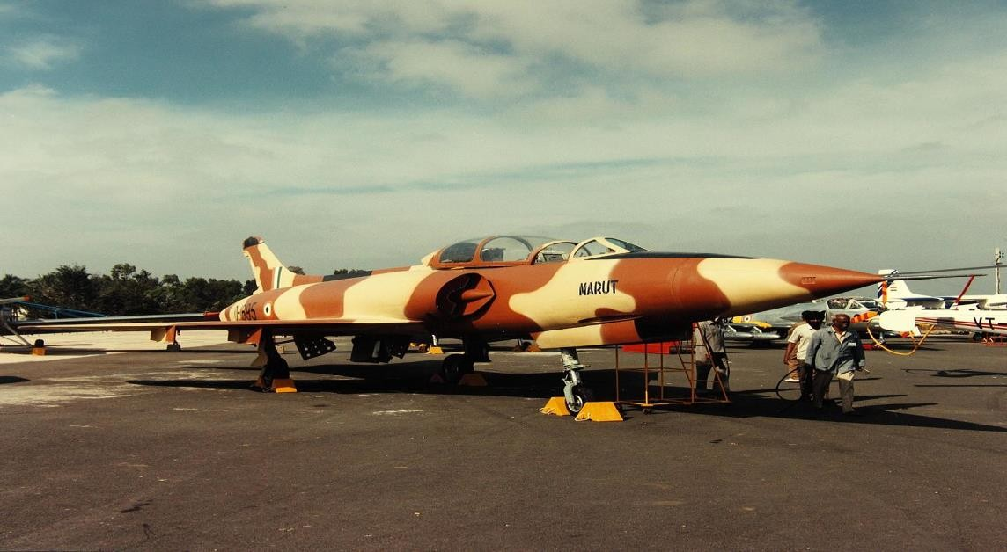

## HISTORY OF HAL

The history and growth of Hindustan Aeronautics Limited is synonymous with the growth of Aeronautical industry in India for more than 79 years.

The Company which had its origin as Hindustan Aircraft Limited was incorporated on 23rd Dec 1940 at Bangalore by Shri Walchand Hirachand, a farsighted visionary, in association with the then Government of Mysuru (Mysore), with the aim of manufacturing aircraft in India. In March 1941, the Government of India became one of the shareholders in the Company and subsequently took over its management in 1942. In collaboration with the Inter-Continental Aircraft Company of USA, the Company commenced its business of manufacturing of Harlow Trainer, Curtiss Hawk Fighter and Vultee Bomber Aircraft.

In January 1951, Hindustan Aircraft Limited was placed under the administrative control of Ministry of Defense, Government of India.

Amalgamation of the two companies i.e., Hindustan Aircraft Limited, and Aeronautics India Limited was brought about on 1st Oct 1964 by an Amalgamation Order issued by the Government of India and the Company after the amalgamation was named as "Hindustan Aeronautics Limited (HAL)" with its principal business being design, development, manufacture, repair and overhaul of aircraft, helicopters, engines and related systems like avionics, instruments, and accessories.

In 1970, a separate division was set up exclusively for manufacture of 'Chetak' and 'Cheetah' Helicopters in Bangalore under license from M/s SNIAS, France. A new division was also established to manufacture aircraft instruments and accessories at Lucknow.

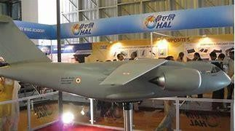License agreements were entered into with M/s Dunlop of U.K. for Wheels and Brakes, Dowty for under carriages and Hydraulic equipment and Normal Air Garret for cabin air pressurization and air- conditioning equipment, Smiths of UK, SFENA and SFIM of France for panel instruments and Gyros, Martin Baker of UK for ejection seats and Lucas for engine fuel systems; for fitment on Marut, Kiran, Ajeet, Chetak, Cheetah, and Jaguar. Similar type of arrangement was agreed with USSR authorities for manufacture of accessories for MiG-21 series of aircraft.



## VISION, MISSION AND VALUES

**HAL VISION**: To be a global leader in the Aerospace & Defense Industry.

**HAL MISSION**: We are committed to deliver superior technology solutions to the customers by leveraging our infrastructure and Design, Manufacture & Service skills, for achieving business excellence.

#### HAL VALUES:

1. Customer satisfaction: We are dedicated to building a relationship with our customers where we become partners in fulfilling their mission. We strive to understand our customers' needs and to deliver products and services that fulfill and exceed all their requirements.
2. Commitment to total quality: We are committed to continuous improvement of all our activities. We will supply products and services that conform to highest standards of design, manufacture, reliability, maintainability, and fitness for use as desired by our customers.
3. Cost and time consciousness: We believe that our success depends on our ability to continually reduce the cost and shorten the delivery period of our products and services. We will achieve this by eliminating waste in all activities and continuously improving all processes in every area of our work.
4. Innovation and creativity: We believe in striving for improvement in every activity involved in our business by pursuing and encouraging risk-taking, experimentation and learning at all levels within the company with a view to achieving excellence and competitiveness.
5. Trust and team spirit: We believe in achieving harmony in work life through mutual trust, transparency, co-operation, and a sense of belonging. We will strive for building empowered teams to work towards achieving organizational goals.
6. Respect for the individual: We value our people. We will treat each other with dignity and respect and strive for individual growth and realization of everyone's full potential.
7. Integrity: We believe in a commitment to be honest, trustworthy, and fair in all our dealings. We commit to be loyal and devoted to our organization. We will practice self-discipline and own responsibility for our actions. We will comply with all requirements to ensure that our organization is always worthy of trust.

## HAL PRODUCTS

1. **LIGHT COMBAT AIRCRAFT:** The HAL Tejas is an Indian single- engine multirole light fighter designed by the Aeronautical Development Agency (ADA) in collaboration with Aircraft Research and Design Centre (ARDC) of Hindustan Aeronautics Limited (HAL) for the Indian Air Force and Indian Navy. It came from the Light Combat Aircraft (LCA) programme, which began in the 1980s to replace India's ageing MiG-21 fighters. In 2003, the LCA was officially named "Tejas”. Tejas has a tail-less compound delta-wing configuration with a single vertical stabilizer. This provides better high-alpha performance characteristics than conventional wing designs. Its wing root leading edge has a sweep of 50 degrees, the outer wing leading edge has a sweep of 62.5 degrees, and trailing edge has a forward sweep of four degrees. It integrates technologies such as relaxed static stability, fly- by-wire flight control system, multi-mode radar, integrated digital avionics system and composite material structures. It is the smallest and lightest in its class of contemporary supersonic combat aircraft.

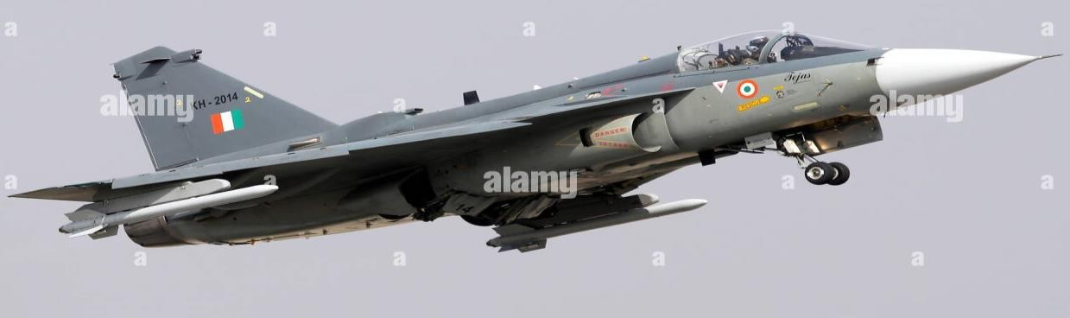

Tejas taking off for demo at Aero India 2017

1. **SUKHOI SU-30 MKI:** The Sukhoi Su-30MKI (NATO reporting name: Flanker-H) is a twinjet multirole air superiority fighter developed by Russia's Sukhoi and built under license by India's Hindustan Aeronautics Limited (HAL) for the Indian Air Force (IAF). A variant of the Sukhoi Su-30, it is a heavy, all- weather, long-range fighter.

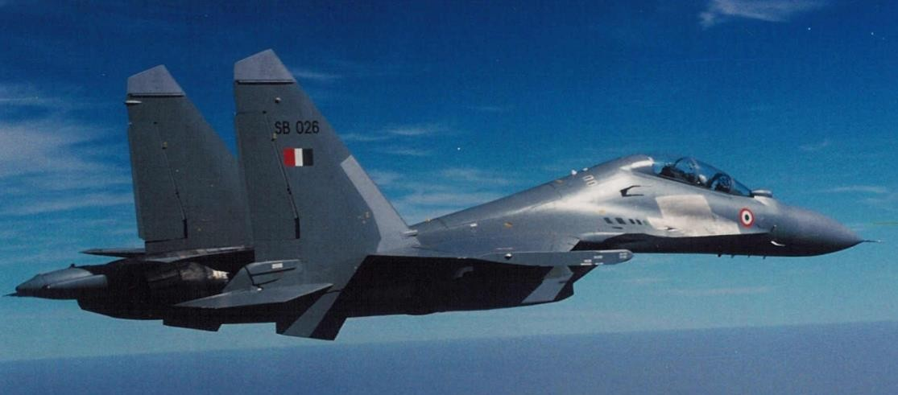Development of the variant started after India signed a deal with Russia in 2000 to manufacture 140 Su-30 fighter jets. The first Russian-made Su-30MKI variant was accepted into the Indian Air Force in 2002, while the first Su-30MKI assembled in India entered service with the IAF in 2004.The IAF has nearly 260 Su-30MKIs in inventory as of January 2020.The Su-30MKI is expected to form the backbone of the Indian Air Force's fighter fleet to 2020 and beyond.

An Indian Air Force (Su-30MK)

1. 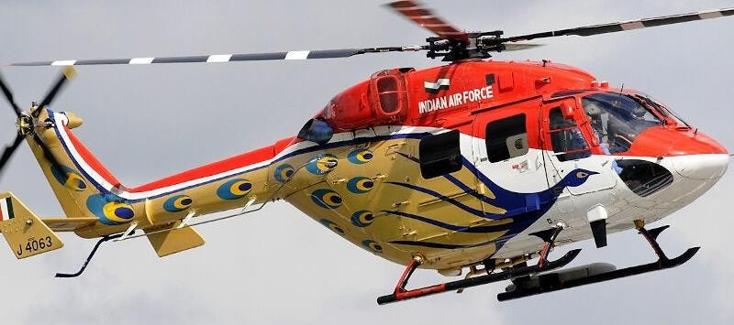**DHRUV**: The indigenously designed and developed Advanced Light Helicopter (ALH-DHRUV) is a twin engine, multi-role, multi-mission new generation helicopter in the 5.5-ton weight class. The basic Helicopter is produced in skid version and wheeled version. Dhruv is “type –Certified” for Military operations by the Centre for Military Airworthiness Certification (CEMILAC) and civil operations by the Directorate General of Civil Aviation (DGCA). Certification of the utility military variant was completed in 2002 and that of the civil variant was completed in 2004. The deliveries of production series helicopters commenced from 2001-02 onwards. A total of 228 Helicopters have been produced by March 2017 including 216 for the Indian Armed Forces.

Advanced Light Helicopter (ALH- DHRUV)

1. **DORNIER**: The 19-seater HAL DO - 228 aircraft is a highly versatile multi- purpose light transport aircraft. It has been developed specifically to meet the manifold requirements of utility and commuter transport, third level services and air-taxi operations, coast guard duties and maritime surveillance.

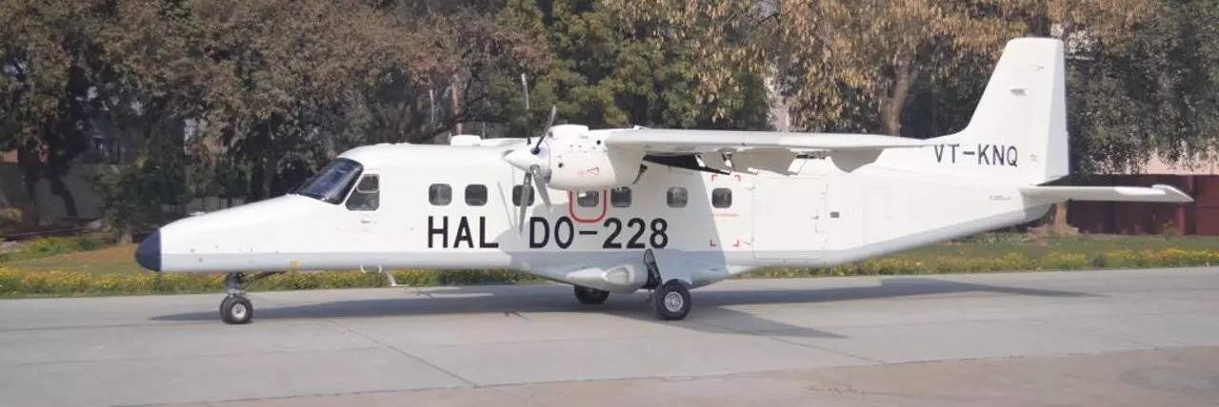In late 2017, the [Directorate General of Civil Aviation](https://en.wikipedia.org/wiki/Directorate_General_of_Civil_Aviation_(India)) issued a type certificate to the Hindustan 228. The aircraft was so far being manufactured under license from RUAG for Indian defense forces and European markets would now be allowed to operate in India for commercial purposes. The 228 made its public debut in 2020 at the Dubai Airshow. [Alliance Air](https://en.wikipedia.org/wiki/Alliance_Air_(India)) signed an agreement with [Hindustan Aeronautics Limited](https://en.wikipedia.org/wiki/Hindustan_Aeronautics_Limited) (HAL) to lease two 17-seater Dornier 228 aircraft in September 2021. The first aircraft was delivered to Alliance Air on 7 April 2022. The HAL Dornier 228 had previously only been used by the [Indian Armed Forces](https://en.wikipedia.org/wiki/Indian_Armed_Forces) but was modified by HAL for commercial operations. Alliance Air deployed the aircraft on a new route connecting [Dibrugarh](https://en.wikipedia.org/wiki/Dibrugarh_Airport), [Assam](https://en.wikipedia.org/wiki/Assam) and [Pasighat](https://en.wikipedia.org/wiki/Pasighat_Airport" \o "Pasighat Airport), [Arunachal Pradesh](https://en.wikipedia.org/wiki/Arunachal_Pradesh) on 12 April 2022, becoming the first airline to use an Indian-made aircraft in civil aviation operations and the first commercial airline in the country to operate the Dornier 228 aircraft.

HAL DO - 228 aircraft

## Hindustan Aeronautics Limited Present Setup

Today HAL has twenty production Divisions/Units, spread over different places in India. These Divisions/Units are fully backed by 10 Research and Design Centers, which are Page 5 of 32 co-located with the production divisions. These centers are engaged in the Design & Development of combat Aircraft, Helicopters, Aero engines, Engine Test Beds, Aircraft Communication & Navigation Systems and Accessories of Mechanical & Fuel systems and Instruments. HAL has five Complexes namely Design Complex, Accessories Complex, MIG Complex, Bangalore Complex and Helicopter Complex each headed by Chief Executive Officers (CEO) except Design Complex which is headed by Director (Engineering and R&D). CEOs and Directors reports to the Chairman and Managing Director (CMD) of the company. In addition, the CMD is assisted by Director Operations, Director (P&A) and Director Finance in Corporate Office, Bengaluru.

#### ACCESSORIES COMPLEX

1. Avionics Division, Korwa: This division is manufacturing advanced navigation & weapon aiming systems, display systems, Cockpit Voice Recorders and Flight Data Recorders.
2. Transport Aircraft Division, Kanpur: This division is manufacturing Dornier aircraft and overhauling these aircraft supplied to IAF, Navy, Coast Guard, Mauritius and Seychelles and overhauling Avro aircraft of IAF and BSF.
3. Accessories Division, Lucknow: It is the manufacturer of all the accessories for different airborne platforms and supplies them to all HAL divisions.
4. Avionics Division, Hyderabad: This division produces all communication and navigation systems e.g., VHF, UHF Communication system for all projects & supplies them to all HAL divisions.

#### MIG COMPLEX

1. Aircraft Division, Nasik: This division is engaged in manufacturing the Sukhoi SU30 MKI, MIG & MIG 21 aircrafts.
2. Aircraft Overhaul Division, Nasik: This division is engaged in overhauling of the variants of MIG 21 aircrafts.
3. Engine Division, Koraput: It is currently engaged in manufacturing of engines for the MIG aircraft. Its additional divisions manufacturing, forging, and casting in its foundry and forging shop for fittings in the MIG series of aircraft.
4. Sukhoi Engine Division, Koraput: It is manufacturing engines for Sukhoi SU-30 MKI fighter aircraft.

#### BANGLORE COMPLEX

1. Aircraft Division.
2. LCA Tejas Division
3. Engine Division
4. Overhaul Division
5. Foundry & Forge Division
6. Aerospace Division
7. Industrial & Marine Gas Turbine Division.
8. Airport Service Centre
9. Facility Management Division
10. IJT-LSP project Group

#### HELICOPTER COMPLEX

1. Helicopter Division, Bengaluru
2. Helicopter MRO Division, Bengaluru
3. Barrackpur Division, Kolkata
4. Aerospace Composite Division, Bengaluru

#### DESIGN COMPLEX

1. Aircraft R&D Centre, Bangalore
2. Rotary Wing R&D Centre, Bangalore
3. Aero Engine R&D Centre, Bangalore
4. Mission & Combat System R&D Centre, Bangalore
5. Strategic Electronics R&D Centre, Hyderabad
6. Transport Aircraft R&D Centre, Kanpur.
7. Aircraft Upgrade R&D Centre, Nasik
8. Aircraft Systems and Equipment R&D Centre, Lucknow, Korwa
9. Gas Turbine R&D Centre, Koraput
10. Aerospace Systems & Equipment R & D Centre, Korwa

## TRANSPORT AIRCRAFT DIVISION (KANPUR)

**HINDUSTAN AERONAUTICS LIMITED - Kanpur** was commenced in 1960 in the name of AIRCRAFT MANUFACTURING DEPOT (AMD) under the functional control of maintenance command of IAF for the manufacture of HS-748 aircraft. Kanpur division of HAL is now known as Transport Aircraft Division. It specializes in manufacture and overhaul of medium and light category Turboprop Aircraft. It was set up in 1960 to manufacture HS-748 (AVRO), a medium- haul multipurpose transport aircraft. Over the years it has vastly developed its infrastructure and capabilities and undertaken the manufacture of Agriculture Aircraft (HA-31), Basic Trainer Aircraft,15- to-19-seater multi role utility Aircraft (DO-228) and a variety of aerospace structure assemblies and component for both domestic and international market.

**Products:**

1. DO – 228 Civil version
2. DO – 228 Maritime Surveillance version
3. DO – 228 Utility transport
4. DO -228 VIP/Executive transport
5. AVRO

## AIRCRAFT NAVIGATION SYSTEM

With the mechanics of flight secured, early aviators began the tasks of improving operational safety and functionality of flight. These were developed in large part using reliable communication and navigation systems. Today, with thousands of aircraft aloft at any one time, communication and navigation systems are essential to safe, successful flight. Continuing development is occurring. Smaller, lighter, and more powerful communication and navigation devices increase situational awareness on the flight deck. Coupled with improved displays and management control systems, the advancement of aviation electronics is relied upon to increase aviation safety.

Clear radio voice communication was one of the first developments in the use of electronics in aviation. Navigational radios soon followed. Today, numerous electronic navigation and landing aids exist. Electronic devices also exist to assist with weather, collision avoidance, automatic flight control, flight recording, flight management, public address, and entertainment systems.

The history of avionics is the history of the use of electronics in aviation. Both military and civil aviation requirements contributed to the development. The First World War brought about an urgent need for communications. Voice communications from ground-to-air and from aircraft to aircraft were established. The development of aircraft reliability and use for civilian purposes in the 1920s led to increased instrumentation and set in motion the need to conquer blind flight—flight without the ground being visible. Radio beacon direction finding was developed for in route navigation. Toward the end of the decade, instrument navigation combined with rudimentary radio use to produce the first safe blind landing of an aircraft.

In the 1930s, the first all radio-controlled blind-landing was accomplished. At the same time, radio navigation using ground-based beacons expanded. Low and medium frequency radio waves were found to be problematic at night and in weather. By the end of the decade, use of high frequency radio waves was explored and included the advent of high-frequency radar.

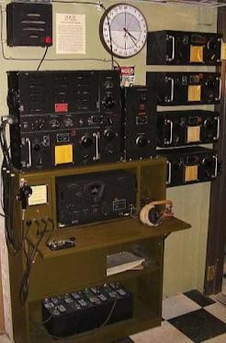During World War II injected urgency into the development of aircraft radio communication and navigation. Communication radios, despite their size, were essential on-board aircraft. Very high frequencies were developed for communication and navigational purposes.

Figure 1. Bomber onboard radio station

## COMMUNICATION SYSTEM IN AVIONICS

Civilian air transportation increased over the ensuing decades. Communication and navigation equipment was refined. Solid-state radio development, especially in the 1960s, produced a wide range of small, rugged radio and navigational equipment for aircraft. The space program began and added a higher level of communication and navigational necessity. Communication satellites were also launched. The Cold War military build-up caused developments in guidance and navigation and gave birth to the concept of using satellites for positioning.

In the 1970s, concept-validation of satellite navigation was introduced for the military and Block I global positioning system (GPS) satellites were launched well into the 1980s. Back on earth, the long-range navigation system (LORAN) was constructed. Block II GPS satellites were commissioned in the mid-80s and GPS became operational in 1990 with the full 24-satellite system operational in 1994.

For the past few decades, avionics development has increased at a faster pace than that of airframe and powerplant development. This is likely to continue soon. Improvements to solid-state continue to this day. Trends are toward lighter, smaller devices with remarkable capability and reliability. Integration of the wide range of communication and navigational aids is a focus.

The communication system in aircraft is used for communication between the crew members and between crew members and ground personnel. It is also used to communicate with the passengers, other aircraft, and ground stations.

Aircraft communications systems comprise the following:

* 1. Radio Communication
     1. HF System – For long-distance voice communications
     2. VHF System – For short-range voice communications
  2. Radio Management Panels
  3. SELCAL System – For selective calling using HF and VHF
  4. SATCOM System – For satellite communication
  5. ACARS – For datalink communication
  6. Interphone Communication
     1. Flight Interphone System – For internal cockpit communication and with ground mechanics.
     2. Cabin Interphone System – For cabin crew or cabin crew/pilots communications.
     3. Service Interphone System – On ground only, for maintenance personnel only.
  7. Ground Crew Call System – To tell ground crew or flight crew there is a call.
  8. Passenger Address System – For passenger announcement from cockpit and cabin crew station.

|  |  |  |
| --- | --- | --- |
| **Band Name** | **Abbreviation** | **Frequency** |
| Very low frequency | VLF | 3-30 kHz |
| Low frequency | LF | 30-300 kHz |
| Medium frequency | MF | 300-3000 kHz (3 Mhz) |
| High frequency | HF | 3-30 MHz |
| Very high frequency | VHF | 30-300 MHz |
| Ultra-high frequency | UHF | 300-3000 MHz (3 GHz) |
| Super high frequency | SHF | 3-30 GHz |
| Extremely high frequency | EHF | 30-300 GHz |

**Radio Communication Basics:** Aviation communication is accomplished using radio waves.

**Radio Waves:** Radio waves are electromagnetic in nature and part of the electronic spectrum. Each wave occurs at a specific frequency and has a corresponding wavelength. The relationship between frequency and wavelength is inversely proportional. A high-frequency wave has a short wavelength and a low-frequency wave has a long wavelength.

**Requirement of Radio Equipment in Aircraft:** The ANO specifies the minimum numbers and types of radio equipment to be carried on aircraft. It is not uncommon to see several radios fitted with different ranges and uses. VHF (Very High Frequency) radio gives good short-range radio reception but is useless on long- distance line-of-sight communication. Here, ground effect radio transmission such as HF (High Frequency) would be used.

**Basic Radio Working:** Radio signals are basically made up of a modulated carrier wave.

The radio transmitter generates an oscillation at the frequency of transmission, for example in the case of VHF this would be in the band of 118-135.975 MHz This is known as the carrier wave because it ‘carries’ the audio information.

Onto this carrier wave is superimposed the audio signal from the microphone (speech). This process is called modulation. There are two methods of modulation – Amplitude Modulation (AM) and Frequency Modulation (FM).

The modulated Radio Frequency (RF) signal is sent to the antenna for onward transmission.

At the receiving end, the antenna picks up the modulated RF signal (probably quite weak by now). It passes this through the coaxial cable to the receiver, where it is amplified then de-modulated, then the audio signal alone is amplified for onward transmission to the speakers or headphones.

**HF Communication System:** HF use was at one time essential for long-range communications, but with the advent of Satellite Communications (SATCOM), its use is becoming less common. However, it is still in use.

The high-frequency (HF) communication system supplies voice communication over long distances. It gives communication between airplanes or between ground stations and airplanes.

The HF system operates in the aeronautical frequency range of 2 MHz to 29.999 MHz. The system uses the surface of the earth and an ionized layer to cause a reflection (skip) of the communication signal. The distance between skips changes due to the time of day, radio frequency, and airplane altitude.

The HF communication radio uses frequency select and control signals to transmit and receive voice communication.

The HF radio modulates an RF carrier signal with voice audio from the flight interphone system. During the receive mode, the HF radio demodulates the RF carrier signal. This isolates the voice audio from the RF signal. The HF transceiver sends the audio to the flight interphone system.

The HF system operates in the frequency range of 2.000 MHz to 29.999 MHz

**VHF Communication System:** VHF radio transmission is the most common system for short to medium-range communication. It provides good and clear communication that is easy to modulate and demodulate.

The very high frequency (VHF) communication system supplies communication over line-of-sight distances. It gives communication between airplanes or between ground stations and airplanes.

The VHF communication system supplies the flight crew with voice and data line-of- sight communication. The VHF communication system can be used to communicate between airplanes and between airplanes and ground stations.

The VHF communication radio is tunable in the frequency range of 118.000 MHz to 136.990 MHz The VHF radio is used to transmit and receive voice communication.

The VHF communication system operates in the frequency range of 118.000 MHz to 136.990 MHz. The 8.33 kHz spacing is only available for these frequency ranges:

1. 118.000 to 121.400
2. 121.600 to 123.050
3. 123.150 to 136.475

### NAV-4000 SYSTEM

**About:** The NAV-4000 includes the VOR/localizer, glideslope, marker beacon and ADF receivers in a single package. The NAV-4500 is identical in size to the NAV-4000 but excludes the ADF receiver. The NAV-4500 is intended for installations offering a single ADF receiver as standard with a dual ADF receiver as an option. If you are looking for a VIR 32/432 replacement then the VIR-4000 is what you want. The VIR 4000 was designed to be a direct replacement for the VIR 32/432 keeping in mind some of the legacy interfaces like CSDB. The Pro Line 21 navigation receivers are designed to support manual radio tuning as well as auto tuning from an FMS. There are many radios tuning options to choose from. Please consult your Collins dealer to choose the tuning option that best fits your needs. All the tuning options available support the DME paired frequency associated with the VOR. Collins, with its long tradition of thinking about the maintenance crew, has incorporated a comprehensive self-diagnostic like no other in the industry. In the rare case the VHF should fail, real time failure status of the VHF 4000 is just seconds away either through the on- board maintenance system or through the controller.

1. NAV-4000 combines ADF with VOR, ILS and marker beacon receivers in a single package
2. NAV-4500 is identical to the NAV-4000, except it does not include the ADF receiver
3. Simplified installation with a single set of high-speed ARINC 429 I/O buses as part of our Pro Line 21 CNS suite
4. ARINC 429 and CSDB tuning and data interfaces support a variety of installation options
5. Lowest size, weight, and power available for business and regional aircraft avionics.
6. Meets DO-160D Change 1 environmental requirements, which allows helicopter and composite aircraft installation
7. Improved maintainability from comprehensive maintenance software accessed through the aircraft’s maintenance computer or shop repair facility

**Features:** Integrated Navigation Receiver

1. Member of the Pro Line 21 CNS product family
2. Incorporates VOR/localizer, glideslope, marker beacon and ADF receivers in a single Line Replaceable Unit (LRU)
3. NAV-4500 is identical in size and pinout to the NAV-4000 but does not include the ADF receiver
4. Saves space by consolidating the functions that are currently housed in two larger units, replacing the VIR-432 and ADF-462
5. Supports CSDB tuning only for the VIR, not the ADF
6. Highly efficient - Offers the smallest size, weight, and power available for business and regional aircraft avionics
7. For new installations, high-speed ARINC 429 I/O buses interfaces with a radio interface unit (RIU-4000) enable features such as software data loading, enhanced maintenance reporting, digital audio, and data communications management
8. Maintain the Pro Line II and 4 series serial data and analog audio interfaces
9. Simplified Installation - Installs with a single set of high-speed ARINC 429 I/O buses
10. Installs in helicopter and composite aircraft
11. ARINC 429 and CSDB tuning and data interfaces (support a variety of install options)
12. 2.5 MCU configuration
13. Some of the VIR & ADF legacy signals that are only required for ProLine II installations have not been included on the NAV-4000/4500 connector
14. Meets DO-160D Change 1 environmental requirements
15. Internal diagnostic capability minimizes time spent on fault diagnosis, code read out available on the CTL or RTU
16. Offers improved maintenance - get comprehensive maintenance software accessed through the aircraft's maintenance computer or shop repair facility

#### A picture containing stationary Description automatically generatedCertification:

1. FAA TSO: C34e, C35d, C36e, C40c
2. EUROCAE: ED-22A, ED-46, ED-47, 1/WG7/70

**Software**: DO-178b Level A (VIR), Level C (ADF)

|  |  |  |  |
| --- | --- | --- | --- |
| **WEIGHT:** | 3.4 lbs. | **DIMENSIONS:** | 2.5 MCU; 2.3"W x 3.3"H x 14"L |
| **TSO:** | C41d, C34e, C36e, C40c, C35d | **TEMPERATURE:** | -55°C to 70°C |
| **ALTITUDE:** | 70,000 ft | **POWER REQUIREMENTS:** | Power Input @ 28V 0.65A / 0.4A |

## AUTOMATIC DIRECTION FINDER (ADF)

Radio waves have directional characteristics. This is the basics of automatic direction finder (ADF), one of the earliest forms of radio navigation that is still in use today. ADF is a short medium range (200nm) navigation system providing direction information it operates within the frequency range 190-1750 kHz, I e., Low and medium frequency bands.

The early aviators used visual aids to guide them along their route; these visual aids would have included rivers, roads, rail tracks, coastlines etc. This type of navigation is not possible in low visibility and so magnetic compasses were introduced. Magnetic compasses were somewhat unreliable in the short term, directional gyroscopes are reliable in the short term but drift over longer time periods. A combined magnetic compass stabilized by a directional gyroscope did overcome this deficiency. The gyro magnetic compass together with an air speed indicator allowed the crew to navigate by estimating their position by extrapolating from a known position and then keeping note of the direction and distance travelled. Errors inevitably led to deviations which accumulated over time therefore crew needed to be able to confirm and update their position.

Later they started using ground base navigation that consisted of a fixed loop antenna in the aircraft tuned to an amplitude modulated commercial radio broadcast station. Pilots would know the location of the radio station. The fixed loop antenna was aligned with the longitudinal axis of the aircraft with the pilot turning the aircraft until he received the minimum signal strength (null reading). This constant turning was insufficient in terms of fuel consumption and caused inherent navigation problems.

The introduction of an ADF these problems. A loop antenna that the pilot could rotate by hand solved some of these problems however this still requires close attention from the crew. Later developments used an electric motor to rotate the loop antenna. Rotating the antenna to determine the null reading from the radio system was a major advantage of this system. Navigation based on ADF became an establish method of travelling.

ADF system provides aircraft related bearings from a selected NDB ground station, and display on HSI page.

The system receives signals within the range 190 KHz 1749.5 KHz with tuning increments off 0.5 KHz.

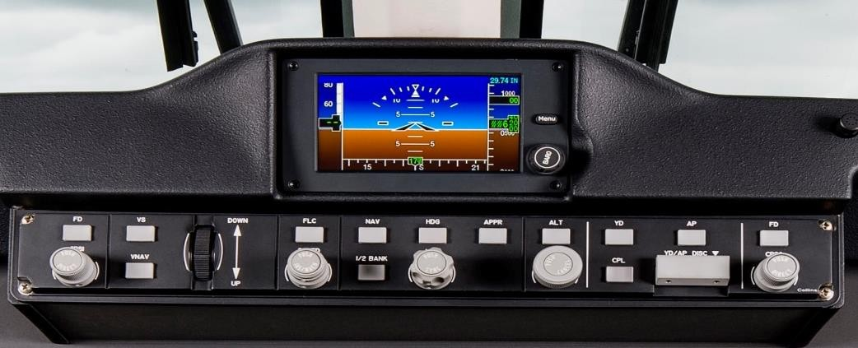Bearing information do this selected ground station is derived by measuring the angle between the beacon signal and the longitudinal axis of airplane.

## INSTRUMENT LANDING SYSTEM (ILS)

ILS stands for Instrument Landing System and is a standard International Civil Aviation Organization (ICAO) precision landing aid that is used to provide accurate azimuth and descent guidance signals for guidance to aircraft for landing on the runway under normal or adverse weather conditions. Instrument landing system (ILS) facility is a highly accurate and dependable means of navigating to the runway in IFR conditions. The ILS provides the lateral and vertical guidance necessary to fly a precision approach. When all components of the ILS system are available, including the approved approach procedure, the pilot may execute a precision approach.

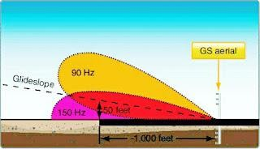

The ILS consists of:

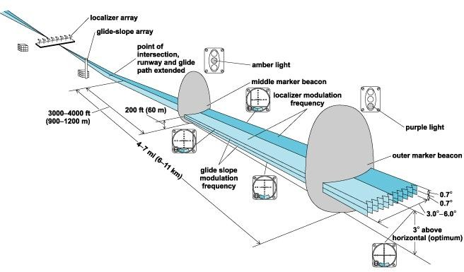

1. **Localizer:** The primary component of the ILS is the localizer, which provides lateral guidance. The transmitter and antenna (Shown above) are on the centerline at the opposite end of the runway from the approach threshold.
2. **Glide Path**: The glide path component of ILS provides vertical guidance to the pilot during the approach. Glide path i s located 750 to 1,250 feet (ft) down the runway from the threshold (shown above), offset 400 to 600 ft from the runway center line.

#### Markers: -

* 1. **Outer Marker (OM):** The outer marker (if installed) is located 3 1/2 to 6 NM from the threshold within 250ft of the extended runway centerline to provide the pilot with the ability to make a positive position fix on the localizer.
  2. **Middle Marker (MM**): The middle marker (if installed) is

located approximately 0.5 to 0.8 NM from the threshold on the extended runway centerline. The middle marker crosses the glide slope at approximately 200 to 250 ft above the runway elevation.

1. **The approach lighting system**: Various runway lighting systems serve as integral parts of the ILS system to aid the pilot in landing. Any or all the following lighting systems may be provided at a given facility: approach light system (ALS), sequenced flashing light (SFL), touchdown zone lights (TDZ) and centerline lights (CLL-required for Category II & III operations.)
2. **Runway Visual Range (RVR):** To land, the pilot must be able to see appropriate visual aids not later than the arrival at the decision height (DH) or the missed approach point (MAP).

**Limitations:** Due to the complexity of ILS localizer and glide slope systems, there are some limitations. Localizer systems are sensitive to obstructions in the signal broadcast area, such as large buildings or hangars. Glide slope systems are also limited by the terrain in front of the glide slope antennas. If terrain is sloping or uneven, reflections can create an uneven glidepath, causing unwanted needle deflections. Additionally, since the ILS signals are pointed in one direction by the positioning of the arrays, glide slope supports only straight-line approaches with a constant angle of descent. Installation of an ILS can be costly because of siting criteria and the complexity of the antenna system.

[ILS critical areas](https://en.wikipedia.org/wiki/Critical_area_(airport)) and ILS sensitive areas are established to avoid hazardous reflections that would affect the radiated signal. The location of these critical areas can prevent aircraft from using certain taxiways leading to delays in takeoffs, increased hold times, and increased [separation between aircraft](https://en.wikipedia.org/wiki/Separation_(air_traffic_control)).

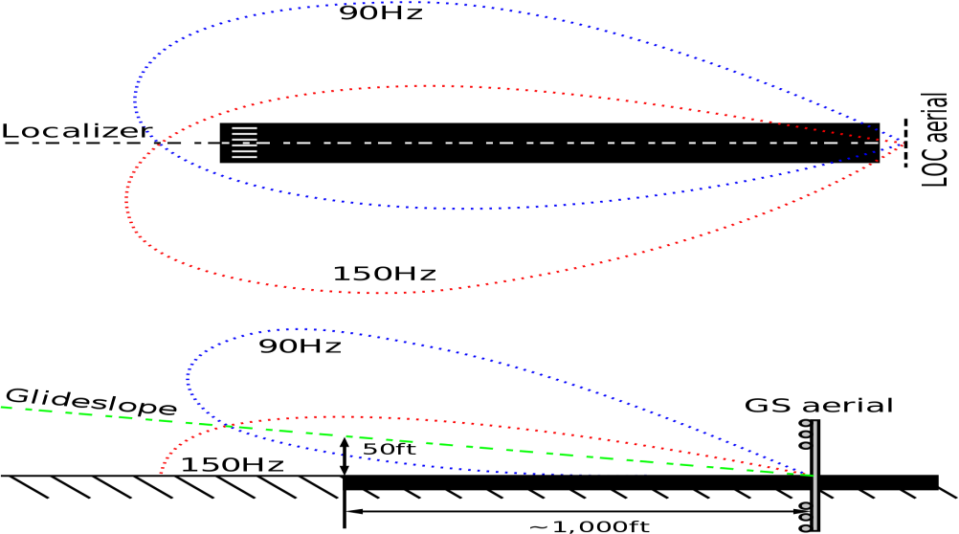

Common type of illustration showing misleading examples of ILS localizer and glideslope emissions

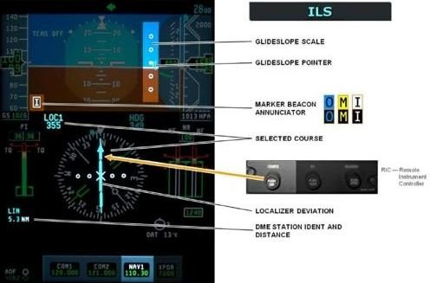**ILS Indications:** To fly an ILS accurately, the pilot must be presented with both lateral information, such that he can assess his position in relation to the centerline and vertical information so that he can accurately fly the prescribed descent profile. The following picture shows the PFD HSI display for an ILS approach.

**VHF OMNIDIRECTIONAL RANGE (VOR)**

One of the oldest and most useful navigational aids for aircraft is the VOR system. The system was constructed after WWII and is still in use today. It consists of thousands of land-based transmitter stations that are called VORs. The ground VOR stations communicate with radio receiving equipment on board aircraft.

**Working:** The position of all VOR stations is marked on aeronautical charts along with the name of the station, the frequency of the station which an airport can tune to use, and a Morse code designation for the station.

VOR uses VHF (Very High Frequency) radio (frequency range 108–117.95 MHz) with a 50 kHz separation between each channel. This keeps atmospheric interference to a minimum but limits the VOR to line-of-sight usage. To receive VOR VHF radio waves, generally a V-shaped, horizontally polarized, bi-pole antenna is used by aircraft. Other types of antennas are also certified. The manufacturer’s instructions for installation location must be followed.

The signals emitted by a VOR transmitter travel 360 degrees around the unit and are used by aircraft to navigate to and from the station using an onboard VOR receiver and display equipment. Because the signal from a VOR station propagates in all directions, a pilot does not need to fly a pattern to intersect it. The radio waves are received regardless of the aircraft's direction of travel if it is within range of the ground unit.

A VOR transmitter sends out two signals that a plane's receiver uses to figure out where it is in relation to the ground station. One of the signals is a reference signal. The second is made by electronically spinning a variable signal. The variable signal is in phase with the reference signal when it is at magnetic north, but as it rotates to 180°, it becomes increasingly out of phase. As it spins to 360° (0°), the signals become increasingly in phase, until they are once again in phase at magnetic north. The aircraft's receiver decodes the phase difference and calculates the aircraft's position in degrees from the VOR ground station. Most planes have two VOR receivers.

**Testing:** To conduct the test, specific points on the airport's surface are designated. Most VOTs necessitate adjusting the VOR radio to 108.0 MHz and focusing the CDI. On the indicator, the OBS should show 0° when showing FROM and 180° when showing TO. The test heading should always indicate 180° if an RMI is utilized as the indicator. although not on 108.0 MHz

## DISTANCE MEASURING EQUIPMENT (DME)

Distance Measuring Equipment (DME) is defined as a navigation beacon, usually coupled with a VOR beacon, to enable aircraft to measure their position relative to that beacon. Aircraft send out a signal which is sent back after a fixed delay by the DME ground equipment. An aircraft can compute its distance to the beacon from the delay of the signal perceived by the aircraft's DME equipment using the speed of light.

Distance Measuring Equipment (DME) is combination of ground and airborne equipment which gives a continuous slant range distance-from-station readout by measuring time-lapse of a signal transmitted by the aircraft to the station and responded back. DMEs can also provide groundspeed and time-to-station readouts by differentiation.

**Frequency:** 960 MHz to 1215 MHz in accordance with ICAO Annex 10

#### Functions:

1. Paired pulses at specific spacing (interrogation) are sent to a ground station from the aircraft via the antenna
2. The ground station (transponder) sends the same pulses back to the aircraft at a different frequency
3. Time it takes is interpreted as the distance, usually in Nautical Miles (NM)
4. Distance is measured in slant range (not horizontal range!) but some units can correct this
5. Slant range error minimized at lower altitudes
6. Operates on the line-of-site principle
7. Reliable up to 199 NM accuracy of better than 1/2 mile or 3% of the distance, whichever is greater (more accurate)
8. Due to the limited number of available frequencies, assignment of paired frequencies is required for certain military non-collocated VOR and TACAN facilities which serve the same area but which may be separated by distances up to a few miles
9. DME is not available on a VOR and would require a separate receiver
10. DME paired with a VOR constitutes a VORTAC
11. Can be identified every 30 seconds or about every 3rd to 4th VOR identification
12. If DME fails above FL 240, continue to next airport where repairs or equipment replacement can be done (must still report as per AIM 5-3-3)
13. GS values, if displayed, are only accurate when flying directly to / from the station
14. Note that Standard Service Volume (SSV) does not apply to airways as they've been certified at their respective distances

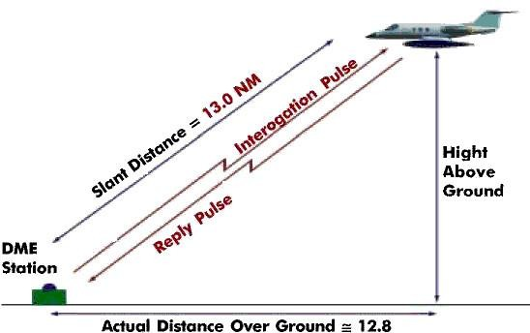

DME Slant Range Distance

**Range:** It is important to note that the distance computed by the DME equipment is a slant range from the aircraft to the ground station. To all intents and purposes tis can be considered a horizontal range until the aircraft is very close to the ground station.

**VOR/DME Pairing:** Each VOR frequency has a specific DME channel paired to it. As a result, when you select the VOR frequency, the DME channel is automatically selected, reducing the pilot workload. It is possible to maintain a DME readout from the current VOR, when changing to another using the HOLD function on the FMS Radio Page. This allows you to maintain a certain DME readout and is commonly used during ILS approaches.

**RADIO ALTIMETER (ALT)**

The Collins Aerospace ALT-1000 and ALT-4000 provide the highly reliable and accurate height information you need for each landing approach. With exclusive digital processing techniques, full end-to-end monitoring and critical-level software verification, the ALT-4000 supports Category IIIa automatic landing systems when installed in a dual or triple configuration and Category II aircraft certifications using a single radio altimeter. Easily upgrade to an ALT-1000 or -4000 from a Collins ALT- 55B or ALT-50A radio by installing the available direct plug-and-replace versions.

1. Accuracy: Delivers crucial height data when it matters most – at low altitudes during landing approach. Accurate to within two feet.
2. Radar height: Measures above terrain up to 2,500 feet.
3. Full temperature/altitude capability: Maintains high performance within a wide range of conditions.
4. Stringent lightning and HIRF hardening: Proven ruggedness for excellent reliability.
5. Lightweight: Each unit weighs 4.7 pounds and includes flexibility for reducing antenna cable weight.
6. Direct plug-and-replace versions: Upgrading to the ALT-1000 or -4000 is easy for customers flying with Collins Aerospace ALT-55B or ALT-50A radio altimeters.
7. Four ARINC 429 digital buses: Eliminates the need for external converters (ALT-4000).

#### Features:

1. Low Range Radio Altimeter
2. Form & fit replacements of discontinued ALT-50A/-55B (see P/N chart below for specific replacement information)
3. Intended for single installations certified for Category II landings and for dual or triple installations in Category IIIa ([ALT-1000](https://www.seaerospace.com/sales/product/Rockwell%20Collins/ALT-1000) is intended for single installations in Category II ONLY)
4. Measures radar height above terrain up to 2,500 feet
5. Accurate to within two feet at the critical low altitudes
6. Entirely digital, allowing for complete end-to-end monitoring
7. Frequency-Modulated Continuous Wave (FMCW) technology
8. Versions with analog outputs capable of driving existing indicators
9. Analog outputs in ALT-55B or ARINC 552A format - strap selectable
10. Four ARINC 429 digital buses
11. Used with ANT-52 antennas
12. Available with standard or shop-adjustable trips (see table below)
13. Full temperature/altitude capability
14. Stringent lightning and HIRF hardening
15. Single unit packaged in a 3/8 ATR short-low package
16. Package and aircraft mounting are identical to the ALT-55B
17. Lightweight at 4.7 pounds with additional aircraft installation delay selections that can reduce antenna weight
18. Front panel computer port for system configuration and access to system faults
19. Computer interface that allows for flight simulation to aid checks of associated systems
20. Versions compatible with Collins FPA-80 Flight Profile Advisory aural alert unit
21. Versions available that directly plug in and replace the ALT-55B/-50A

**Specifications:**

|  |  |  |  |
| --- | --- | --- | --- |
| **DIMENSIONS:** | 3.313" H x 3.562" W x 13.925" L | **SOFTWARE:** | DO-178B Level A (critical) |
| **COOLING:** | No forced air required | **ENVIRONMENTAL:** | DO-160C, /A2F2/BB/ CLMNY/E1XXXXXZ/  BZ/AZ/AZ/ Y/AZ/Z3Z3/XX |
| **ALTITUDE:** | 55,000 ft. | **WEIGHT:** | 4.7 lb. |
| **CENTER FREQ:** | 4300 ±15 MHz | **TEMPERATURE:** | -55°C to 70°C |
| **MODULATION:** | Selectable, 49, 50 or 51 Hz | **POWER REQ:** | 28 ± 20% V DC, 16 W |
| **ALTITUDE OUTPUTS:** | Four isolated buses | **RF POWER OUTPUT:** | 350 mW nominal |
| **ANALOG:** | Two isolated outputs, strap selectable mode | **LINEAR FM DEVIATION:** | 100 MHz, nominal |
| **ALT-55 MODE:** | -20 to +500ft; 0.02(h+20) V dc | **DIGITAL:** | Binary Label 164; BCD Label 165 per ARINC 429,  707 |
| **OUTPUT LOADING:** | 20 standard loads per bus(digital); 1mS max (analog) | **ARINC 552A MODE:** | -20 to +480 ft; 0.2 (h+20)  Vdc +480 to +2,500ft; 10 +  10 In Vdc |
| **TRIPPED OUTPUTS:** | < +1.5Vdc @ 100mA max | **SYSTEM ACCURACY:** | 500 to 2,500 ft ±3% |
| **TIME CONSTANT:** | 0.09 ± 0.01s | 360 | |
| **UNTRIPPED OUTPUTS:** | < 20µA @ 30Vdc max |
| **DELAY (AID) SELECTIONS:** | 20, 26, 32, 40, 46, 52, 57, 63ft |

**REFRENCES**

1. Dornier Assembly Hangar
2. Observation
3. Discussion
4. HAL Official Website
5. Ground Studies of Pilots - Navigation
6. Avionics Navigation System (Myron Kayton & Walter R. Fried)
7. Airport Engineering Desk Reference (B/H)
8. Google Search
9. Google Images